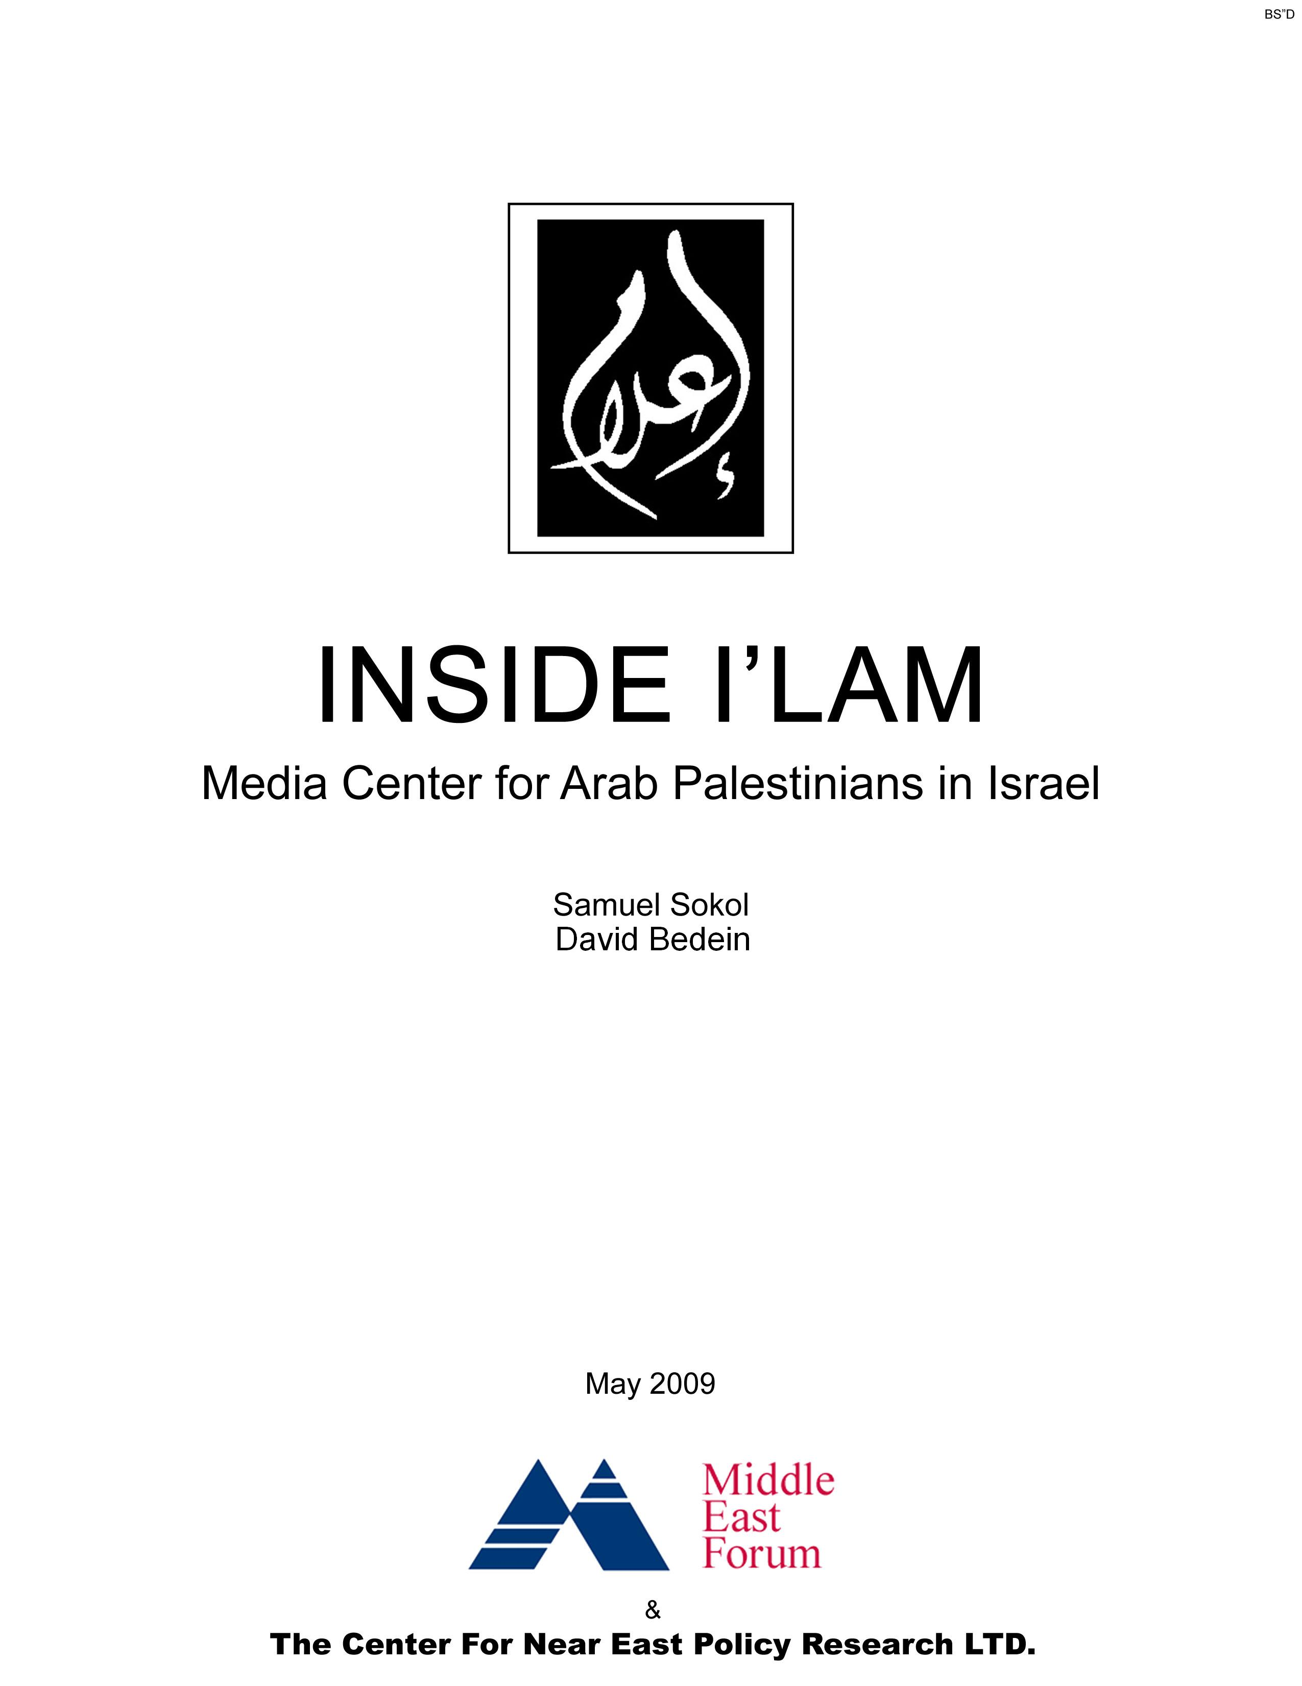

Center for Near East Policy Research Ltd.

Beit Agron International Press Center
37 Hillel Street, Jerusalem 94581
Israel

POB 1783
1295 Beacon Street
Brookline MA 02446
USA

Policyresearch1@yahoo.com

1-800-969-9716

CONTENTS

OVERVIEW
PG. 4

PREFACE
PG. 5

FUNDING
PG. 7

PUBLIC ACTIVITIES
PG. 11

ATTITUDE TOWARDS ISRAELI POLITICAL DEVELOPMENTS
PG. 12

DISSEMINATION OF NEWS THROUGH ISRAELI JOURNALISTS
PG. 18

PERSONNEL
PG. 19

AFFILIATED NGOs
PG. 26

SUMMARY
PG. 28

Supplemental material is available online at http://ilamreport.blogspot.com/

OVERVIEW

I’lam (pronounced E’e’lam): Media Center for Arab Palestinians in Israel is a non-profit, Non-Governmental Organization (NGO number 580355600.) based in Nazareth, Israel. Its aim is to promote civic equality within the public domain and to advocate for the benefit of Arab media interlocutors and Arab institutions. I’lam’s stated mission is “promoting media rights and empowerment.” At the same time, I’lam focuses much of its efforts towards the de-legitimization of Israel as a Jewish state and its defamation abroad.

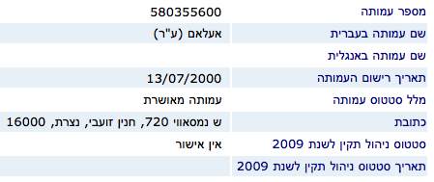
I’lam NGO registration information. Updated 06/01/2009
(Israeli Justice Ministry רשות התאגידים - רשם העמותות)

I’lam and its staff members have promoted…
- The notion of a massacre in Jenin during Israeli anti-terror operations in 2002.
- The calumny that the recent incursion in Gaza was a massacre.
- Comparisons between Nazis and IDF service personnel.
- Unsubstantiated accusations of cold-blooded murder of journalists.
- Accusations of Israeli security personnel acting as death squads while enforcing the law with the Israeli-Arab public.
- The Palestinian “Right of Return”.
- Jerusalem’s status as an Arab cultural capital as well as a soon to be political capital by right as opposed to a Jewish capital.
- The Palestinian identity of Israeli-Arabs and the solidarity between Israeli-Arabs and the Hamas led Arabs of Gaza.
- The ideology that the creation of the State of Israel in 1948 was a disaster (Nakba).
- The very idea of a Jewish state is racist.
- The position that national service is illegitimate for Arab citizens of the state of Israel.
- Hamas as the legitimate representative of the Palestinian people.
- The replacement of Israel with a Palestinian state.
- Their right to express disloyalty to Israel and to demand their rights as citizens of Israel.

I’lam engages in media analysis which is highly tendentious, accusing the Israeli press of wanton distortion and even of inciting the murder of innocent civilians. While engaging in such behavior, I’lam has worked to defend Israeli-Arabs who have violated the state’s incitement laws. In fact, I’lam board member Anton Shalhat was himself prevented from leaving the country by former Prime Minister Sharon due to the risk that he posed to state security.

I’lam is funded by, among others, the New Israel Fund (NIF). The NIF receives donations from many Jewish Federations and organizations in the United States. Many American Jews may not be fully aware of I’lam’s activities.

PREFACE

I’lam was founded in 2000 by a group of Israeli Arab academics and journalists who have opted to identify themselves in their literature as “Palestinians”, including current Balad party MK Hanin Zoabi, who has recently expressed support for Iranian nuclear capability. I’lam cites the Events of October 2000 in which 13 violent Arab rioters were killed as having shaped its early work.

I’lam defines itself as “a unique civil society initiative dedicated to analyze and strengthen the relationship between media and democracy in Israel. We reach this by empowering the Arab media landscape and by democratizing Israeli media policies and practices, influencing Israeli media institutions to adopt more professional and unbiased standards in their coverage of Arab citizens of Israel. “

I’lam divides its work into two categories “promoting media rights and empowerment.”

Former PLO communications and legal consultant Sanaa Hammoud serves as director.

Until the recent Knesset election, Hanin Zoabi of Nazareth served as director. She claimed to have had no knowledge of certain activities of I’lam in regards to defending inciters when asked in an interview.

Board of Directors

The current board of Directors of I’lam consists of
- Mr. Anton Shalhat, Editor at Madar Institution
- Ms. Sanaa Hammoud, former Al-Jazeera newswoman and PA employee
- Mr. Yosef Danial
- Mr. Aied Ali Essalih.
- Adv. Sonia Boulos, lawyer from the Association for Civil Rights in Israel (ACRI)

The I’lam board in the past has included
- Wadea Awawdy, Palestinian Journalist living in Kafar Kanna
- Rana Balan
- Marzouk Halabi
- Mustafa Kabaha, Lecturer at the Open University and at the Emek Yizrael Academic College

Staff

I’lam’s staff currently consists of
- Nasser Victor Rego, International Relations Coordinator
- Ms. Kholod Masalha, Hebrew Media Projects Coordinator
- Mr. Zaher Boulos, Empowerment Program Coordinator
- Ms. Evvette Hassan, Office Manager
- Ms. Ola Ghali, Accountant
- Mr. Izzat Shlon, External Accountant

I’lam’s staff has previously included the following people
- Heidi Paredes- development director
- Maysaa Abu El-Haija- media rights program
- Nadim Natour- production center
- Amal Jamal- media researcher
- Mona Zaher- research assistant
- Yathreb Zoubi- media monitoring assistant
- Hanna Shames- freelancer and practical trainer
- Safa Adawi, Freelancer
- Nayera Nqula, Media Monitoring Staff
- Rana Fahoum, Media Monitoring Staff
- Jennifer Scott, Research and Development
Audit Committee

The Audit Committee oversees the administrative and financial actions of the organization and approves the financial report. Currently sitting on the Committee are:
- Ms. Sozan Ngedat, Media Graduate
- Ms. Hiba Zoubi, Media Instructor and Freelance Journalist

According to an email sent out by former ACRI spokeswoman Tally Gur on the Act Left Yahoo group, Haifa Declaration signer Mr. Salman Natour has served at as the President of I’lam.

It is the intention of this report to provide an overview of how I’lam fits into the Israeli fabric.

FUNDING

According to their website I’lam is currently supported by
- The Ford Foundation Israel
- Open Society Institute
- The New Israel Fund
- Welfare Association (Al-Taawon)
- Al-Quds Capital of Arab Culture
- Goethe Institution
- The European Union

Some of I’lam’s patrons are no longer listed on their website. However, these changes can be seen from an NGO-Monitor report that states that “According to its website, I'LAM is funded by the Swiss Federal Department of Foreign Affairs, the New Israel Fund, the Heinrich Boell Foundation, and the Foreign Office of the British Council as well as the support of the Open Society Institute Development Foundation. In addition the EU's European Initiative for Democracy and Human Rights (EIDHR) has accepted a funding proposal from I'LAM for its project "Responsible and Professional Media".

The European Union lists I’lam as having received €553,132 in funding for the Responsible and professional media project on its website.

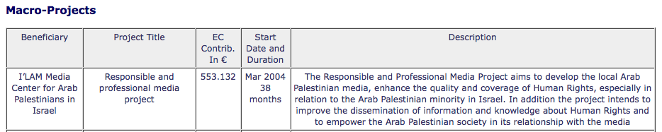

In the European Commission’s List of ongoing contracts managed in Israel – updated 24/04/08 I’lam is listed as receiving €548,884 in funding.

Al-Quds: Capital of Arab Culture
This group lists both the Palestinian Authority Ministry of Culture and ALECSO: The Arab League Education, Cultural and Scientific Organization as partners. It is highly instructive that an Israeli NGO should be receiving disbursements from an organization affiliated with both the PA and the Arab League, which is in a formal state of war with Israel.

The Al-Quds organization maintains an explicitly anti-Israel stance on its website, stating that “We also aim at consolidating the political dimension of al-Quds as the capital of the independent State of Palestine and its status within religious and human consciousness and to support Palestinian presence and steadfastness within it, in order to confront the Israeli occupation’s measures and consolidate the feeling of Arab national allegiance towards a unified Arab culture.”

Its goal is to “promote Jerusalem’s historical and cultural identity as the capital of the State of Palestine.”

The Al-Quds organization has also accused Israel of forcing Arabs on death marches.
They have made comments such as “Encircled by violent, abusive gangs, we were forced to march east through rough, arid, mountainous terrain, until we reached Arab controlled territory. The heat and thirst were an agony, which killed many old people and children.” and “The moment that I wanted to return to my group carrying the water for my siblings, a military jeep suddenly arrived stopping a few steps away from me. A Zionist officer stepped down and pointed a pistol to my head. He then ordered me in broken Arabic: “Throw water… Throw water’.”

Welfare Association
The Welfare Association is alleged to work “together with the Al Aqsa humanitarian fund - which is a bogus 'charity' whose offices were shut down in several European countries for being tied to terrorism. The funding being given to perpetrating this perfidious view of history (and malifide exploitation and misappropriation of Holocaust jargon and leitmotiefs) is another example of how the EU, UN, World Bank and other NGO's are aiding and abetting incitement to terrorism.” According to both the American and Israeli governments, The Al-Aqsa Foundation is a terrorist front.

On the website of the UK branch of the Welfare Association is a text stating that they donate to a group called Al Aqsa Appeal “Nearly 400 ANN views have donated over £150,000 through the ‘Al Aqsa Appeal’ broadcasts.“ and according to Miftah “PBC also allocated large space of its live coverage to reactions on Israeli excavations,though broadcasting images footage of these excavations and their gravity, such as'Kalam Masmouh' (permitted talk), 'Sarkhat Al-Aqsa' (Al-Aqsa appeal) and 'YawmAl-Quds' (the day of Jerusalem).”

The New Israel Fund (NIF)
The NIF remains a major source of funding for I’lam, as indicated by the financial statements on the NIF website.

In funding I’lam, the NIF seems to have changed its policy of not supporting an organization that advocates for the right of return as stated emphatically to reporters last year.

When asked about this policy, an NIF spokesperson replied that there is no such policy, nor has there ever been one. The NIF official stated that the NIF respects Israel as a Jewish and democratic state. However, the spokesperson said that the NIF did not expect ideological conformity from their “progressive” grantees. Nor did the NIF official see anything incongruous between NIF endorsing Israel as a Jewish state while simultaneously funding efforts to undermine Israel’s status as such.
In an email statement, another NIF representative wrote that “The New Israel Fund does not require ideological conformity from its grantees, and we differ with many of them on key issues. What we look for in grantees is the ability and track record to make a difference in advancing real social change in Israel, and a general commonality of values. Supporting I’lam’s work in no way signifies that NIF agrees with their position on the right of return or other difficult issues, only that we expect them to conform to our very rigorous standards for using our grant to execute their work."

According JTA news article about the New Israel Fund “NIF grantees, including NIF-Ford grantees, must devote the funds to ‘charitable and educational purposes’ and not ‘carry on propaganda or otherwise attempt to influence specific legislation, either by direct or grass-roots lobbying.’”
I’lam engages in both propaganda and direct lobbying efforts. Furthermore, by calling for the right of return in the Haifa Declaration and in meetings and proclamations of the Forum of Journalists, I’lam is engaged in grassroots lobbying within the Israeli-Arab community.

2004 Annual Report

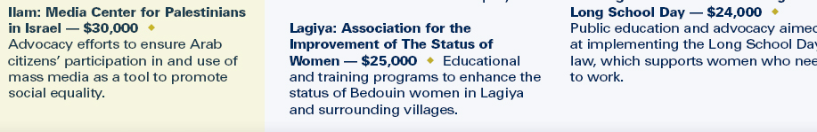

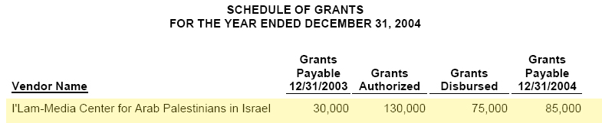

2005 Annual Report
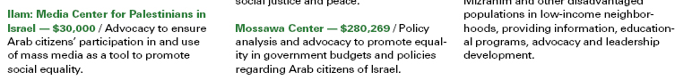

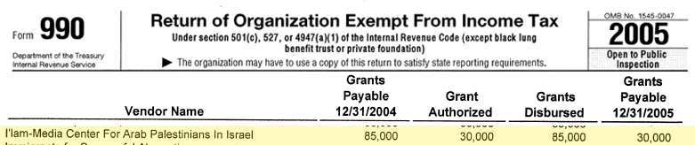

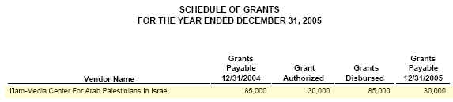

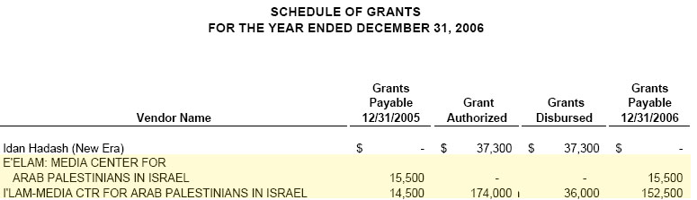
Note that I’lam is listed twice as if it were two separate organizations.

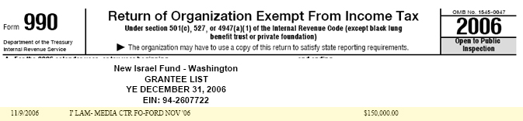

The 2006 Annual Report
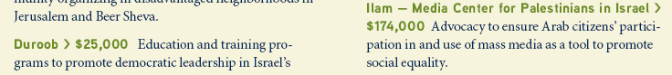

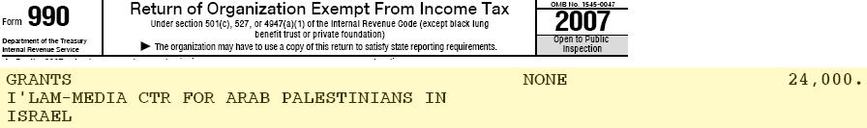

2007 Combined Financial Statement
I’lam is once again listed twice under different spellings.

2007 Annual Report
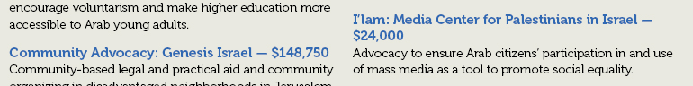

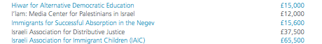

PUBLIC ACTIVITIES

I’lam describes its activities as follows. ”Our approach can be seen as two-fold: promoting media rights and empowerment.
Media Rights supports impartiality, fairness, and equity in Israeli media policy, in conformity with democratic values. Furthermore, we encourage Israeli media institutions and practitioners to adopt more professional, unbiased standards in their coverage of the Arab citizens of Israel.
Through Empowerment we aim to empower Arab society, particularly Arab journalists, by promoting equal access to the Israeli media, by encouraging the free flow of information and representation at media bodies and institutions, and through the fostering of professional standards.”

Some of I’lam’s ostensibly neutral activities include
- Running tours for Journalists in Arab towns throughout the country.
- Creating the media charter- a code of ethics for Arab media professionals.
- Running programs for high school students and NGOs in which participants learn how to shoot and edit and produce videos.
- Lobbying for equitable treatment when Arab journalists run into discrimination.
- Working towards the establishment of an Arabic language television channel in Israel.
- The creation of a Forum of Journalists for Arab media professionals.

As I’lam states in its literature "Through our work we aim to empower the Palestinian media landscape and society by promoting equal access to the Israeli media, encouraging a fair information-flow, and fostering professional standards. We seek to strengthen the commitment of Palestinian media institutions towards the Palestinian society addressing their real media needs. In addition we aim to shape Israeli media policy to support impartiality, fairness, and equity and to influence Israeli media institutions to adopt more professional and unbiased standards in their coverage of Palestinian citizens of Israel."

“A main aim of I’lam’s work is to increase Arab representation and number of Arab workers at all channels… and media institutions…To facilitate the achievement of this goal, I’lam gathers data… prepares position papers, and submits lists of Arab human resources that could be included.”

“In cases where there is a discrepancy between legal obligations and on-the-ground developments, I’lam initiates legal steps.”

However, the subtle intentions of I’lam can be discerned by examining their press releases, publications and films.

ATTITUDE TOWARDS ISRAELI POLITICAL DEVELOPMENTS

The Armed Struggle
Hanin Zoabi, currently an MK with the Balad party served until the recent Knesset elections as the Director of I’lam.

She attended a conference of Arabs against national service and the following is attributed to her speech: “Ms. Haneen Zoabi from ‘Ilam’ centre spoke against civic service from a historical point of view. Ms. Zoabi also emphasized the importance of the participation of youth in deciding their own futures and the future of their people. She said that we do not need to find an alternative to civic service.“

This dovetails with a statement found on the I’lam website in which national service is seen as a tool of oppression. “…the confiscating of Palestinian national identity as a result of Israeli policy and the Israeli civil service effort in the Arab community as another strategy towards that same goal.”

In light of the demand by I’lam that Arabs be given equal rights under the law, it seems incongruent that they speak out against service to the state which grants the very rights they desire.

This is in keeping with a previous statement made after the elections by MK Zoabi in which she states “Balad’s achievement and the fact that it increased its strength are a response to Lieberman and those like him. […] Balad’s concept, which rejects the “Jewish state” idea, is the only idea that can remove Lieberman from the circle of political and moral legitimacy. […] When you agree with the “Jewish state” idea, you necessarily agree with the idea of loyalty to this state. Rejecting the “Jewish state” concept will block the road for anyone who demands our loyalty to such a state. There is no logic in demanding that I be loyal to an idea to which I do not agreed to begin with, especially since I am proposing an alternative and fighting for it. […] The language of democracy
does not speak of loyalty. This is a language of fascism, just like Lieberman. The
language of democracy speaks of rights, equality, and values.”
(www.arabs48.com, February 13, 2009).

Zoabi has made the following comment regarding the armed rebellion against Israel “We don’t live in the territories, we cannot throw stones and we cannot participate in the legitimate resistance against occupation.” –Emphasis added

I’lam’s views can be seen in its use of the term Arab Palestinians in Israel instead of Israeli-Arabs. The implication of this terminology is that the members of I’lam identify with a foreign and hostile national movement and do not identify with the state of Israel.

Murder, genocide and ethnic cleansing
I’lam uses the terminology of murder and genocide in describing the anti-terror activities of the Israeli army. One of the clearest cases is an article by Hisham Naffa’a that was posted on the I’lam website and listed under Publications called Report from Jenin Refugee Camp: Even Flies Reveal What the Israeli Army Wants to Hide.

The following are some selected excerpts from the article.
- “What can be said to a man mourning the death of his two executed brothers - cold blood execution.”
- "We were handcuffed for two days. For two days we had no food. Then they gave us food and water, a small piece of bread and a cucumber. This was supposed to last for another two days."
- "There was a handicapped child at his Uncle Rashid's house. They blew up the house on top of them. They blew it up...God is mightier than Israel."
- "One night," Majida says, "the army put many families in one apartment, without food, without water. They had children. They began screaming and crying. The army came back to threaten them with dogs..."
- “How was this room before the massacre?”
- “The soldiers are the grandchildren of the Nazis' victims, the Nazis' survivors. They have come here to consume food quickly and consume life quickly. This is the true image of Israel. The real Israel is not in the clean, lofty suburbs of Northern Tel-Aviv...It is not in the literary cafes and journalists' clubs...It is not its High Court. I saw the real Israel, its ugliness in the Jenin Refugee Camp on Monday, April 15, 2002. The rest remains decor for murder.”
- “He tells us of how he saw the army bring five men together and made them face the wall with hands above their heads. He saw everything. He was very close. A group of soldiers came and shot the five men. Waleed is terrified. Two of the executed men were his brothers.”
- “Unlike all Israeli military correspondents who came here before us and convey to their readers what their military masters demand – these are the military masters that turn journalists to their spokespersons – even the flies can reveal to us what they want to hide.” –Emphasis added

On April 22nd 2006 I’lam put out a press release/news story on Electronic Intifada called Land Day protests highlight Israel's continuing attempts at ethnic cleansing. I’lam, instead of working towards the rights of Israeli-Arabs, perpetuates claims of ethnic cleansing -a term closely connected with genocide and considered a war crime- in its publications.

I’lam distributed a video entitled “Lama Zafouk” written by Eyas Natour regarding the 2000 riots in which Israeli Arabs burned tires, threw Molotov cocktails and attempted to trash Jewish neighborhoods.

The video is cut to make it look like the police are attacking Arabs in an unprovoked fashion. No Arab violence, which caused the clashes, is shown. There is no mention of the attacks on Jewish citizens.

They have a man on the video claiming, “Three soldiers went down, wearing green. They went down to this area. They beat two young men, that were hiding under the olive tree, and killed them in cold blood at a range of two meters.” (See video at 3:32.) –Emphasis added

Afterwards in the video, the mother of one of the Arab rioters refers to him as a “martyr”.

The following is from I’lam’s description of the video. “The person who issued the orders stood still and relaxed watching as young men were shot like birds. Young men that liked to sing, draw, and feel, and whose only mistake was to love their Palestinian identity and people.” –Emphasis added

I’lam has also engaged rewriting contemporary history in its description of the Arab riots of October 2000.

According to I’lam’s 2004 newsletter “On September 28, 2000, the right wing Likud leader, Ariel Sharon attempted to forcibly enter the Al-Aksa Mosque in East Jerusalem. When Arab citizens attempted to prevent Sharon from entering the mosque, police responded with alarming force, brutally beating the protesters. It was this infamous visit to Al-Aqsa Mosque, the third holiest site of the Islamic faith, that gave birth to more than a month of violence between the police and both Jewish and Arab demonstrators in which 13 Arab died at the hands of police and IDF forces.” –Emphasis added

I’lam also claims that the Israeli authorities have engaged in targeted killings of Arab journalists. On its website I’lam makes the following claim.
“Did you know that…”
- “…Israeli authorities have been responsible for over 400 violations of journalists’ rights in the Occupied Palestinian Territories, ranging from mere bureaucratic harassment to outright killings?”
- “I’lam found that Israeli Authorities violate the legal, professional, and physical rights of these journalists at nearly every level?” –Emphasis added

I’lam has also claimed that there is a “Media Suppression Policy of the Israeli Government”.

I’lam participated in a program called Crossing Borders. I’lam employee Kholod Masalha helped in preparing Crossing Borders magazine vol. 10 no. 38. Hard copies of this magazine are distributed from their offices in Nazareth while I’lam links to it on their website.

According to I’lam “In June, Kholod Masalha was responsible for organizing a workshop for the journalists from Palestine/Israel that would be participating in the Crossing Borders programme. Kholod was among five journalists selected to organise this workshop.“ Masalha was not only the organizer of the Israeli-Arab faction within the program, whose members wrote many of the objectionable articles in the magazine, but as a participant in the program, helped in preparing the magazine for publication.

The following are some of the statements from Crossing Borders
- “…we realized that it [the IDF Gaza incursion] was a new massacre and aggression that would change our lives.”

- “Mosques were destroyed during prayers…homes were attacked randomly, causing the death of whole civilian families.”

- “…I do know that many children, women and civilians were killed in their homes, unarmed people whose only concern was to live in peace like children and civilians everywhere.”

- Hamas is billed as the “legitimate representative of the Palestinian people.”

- The Jewish people are “blinded with hate” and this is the reason given for the elections committee banning the Arab parties and not their history of treasonous statements.

- They claim that there were “weeks of continous mass killings and mass destruction in Gaza…”

- They misrepresent the checkpoints as arbitrary blockages and take the context of terror away. Before the intifada Arabs could travel rather freely.

- “The Palestinians’ dream of emancipation can only be achieved through replacing the Israeli state with a Palestinian one…” –Emphasis added

- “I hope and dream of the return of the Palestinian people to their homes during the upcoming year as their return is more important than establishing the Palestinian state.”

I’lam accuses the Israeli media of serious crimes of which it and much of the rest of the Arab language media is guilty.

In I’lam: Summary of Israeli Media Performance during Lebanon War 2006 I’lam can be found “demanding from the Israeli media to avoid the militant, patriotic performance that it adopts.” I’lam questions why Israeli media would show patriotism or support the troops in wartime.

Regarding the conduct of the press during the Second Lebanon War I’lam claimed the following
- That the Hebrew media contained “Encouragement for killing and destruction…”
- “The editors of Ma’ariv “call for the destruction of cities, wiping out villages and killing children. It would appear that the most basic right to life and a roof over one’s head are absent from their consciousness.”
- “The editor in chief of Yediot Aharonot calls for hitting innocents.”
- The editor in chief of Yehiot Aharonot issued a “call to kill civilians.”
- That the Israeli media issued “the call to kill innocent civilians [is] the worst of incitements.”
- The Israeli media contained “the justification of the killing of innocents…”

I’lam went so far as to accuse the Hebrew press of “Inciting against the leaders of the Arab public” during the war. When the Arab community protested against Israeli acts of self-defense and expressed solidarity with an enemy during wartime I’lam claimed that “During the war, the Hebrew media viewed the Arab society and Arab political positions from the viewpoint of the Zionist consensus [which I’lam views as illegitimate], and did not even recognize the Arab’ right to formulate a political position of their own, which might be opposed to that of the Zionist’s.”

There is a discrepancy between I’lam’s expectations for the Arab media and its rights and what it grants to the Jewish media as I’lam stated “The Israeli media should not shape public opinion that is separate from its surrounding environment [the Arab world] and from international public opinion.”

This is substantiated by I’lam’s objection to the media’s “hegemonic ideology that seeks to reinforce the Jewish character of Israeli society, promote Jewish culture, and foster closer relations with the Jewish Diaspora…”

The Arab MKs in Israel’s Knesset have engaged in acts of incitement and sedition. On 7.4.06 MK Abbas Zachur stated that “We are proud of Hamas and all those who help it.” Ignoring this reality, I’lam alleged that “The Israeli media contributed to the distribution of incitement and hostility against the Arab MKs.”

When discussing the Israeli-Arab violence in response to the Second Lebanon War. I’lam tried to place blame on the Israeli police and called accurate reporting misleading. “Thus the event, which started out as a political protest [against Jewish self-defense in the face of Hamas rocket attacks on the Negev], turned into an outburst of rampage and violence against the police, which prevented the protest from presenting its central political message. The information broadcast, of ‘rampage’ and ‘disturbing the peace’ was, at the very least, misleading.” As with the case of Ariel Sharon listed, this case illustrates I’lam’s tendency to blame Jews for Arab violence

Discrepancies
I’lam has stated that the Jews discriminate against Muslim media outfits by not advertising with them and then goes on to state that they do not want Jewish funds. Yet I’lam is funded primarily by the NIF, a Jewish organization.

I’lam implies that private companies are required to subsidize the Arab media when they complain that they are highly dependent on private companies for advertising revenue and that “a mere 1 – 1.5% of the total advertising budget towards the targeting of this society.”

In one of their forums “Participants agreed that fostering professionalism must be coupled with an individual and collective decision on the part of Arab media actors at all levels, to end the economic dependency on Israeli public and private advertising monies. Hence the need to foster and develop independent resources in order to adequately finance Arab media institutions.”

Mossawa and I’lam
The Mossawa Center The Advocacy Center for Arab Palestinian Citizens of Israel put out a report entitled "BLACK OCTOBER" Israel Slaughters its Own Citizens
in which they I’lam is cited as a contributor. “The information printed in this text was supplied by MOSSAWA, I'LAM, and ADALAH.”

Mossawa and I’lam claimed that “We are in need of protection from the massive killing by Israeli forces.”

The report also claimed that during October 2000, all violence was initiated by Israeli government forces and no mention was made of the many attacks on Jews perpetrated by Israeli-Arabs.

Claiming Jerusalem for Palestine
I’lam, in a press release, issued the following statement. “Repressive measures such as the military patrolling of streets, physical obstruction, arrests and an outright illegal ban on cultural activities without due process will not liquidate the fact that Jerusalem is the capital of Arab culture and will be the future capital of a Palestinian state, and tomorrow will be the focal point of the Arab and Islamic world and the progressive forces in the world.”

DISSEMINATION OF NEWS THROUGH ISRAELI JOURNALISTS

I’lam lists a number of members of the Hebrew media as having a connection or collaborating with I’lam in its 2004 annual report.

- Raffi Menn (Maariv)
- Amir Gilat (Maariv)
- Miron Rappaport (Haaretz)
- Miki Miron (Reshet Bet)
- Roni Shaked (Ydeot Aharonot)
- David Retner (Haaretz)
- Carmel Lutzati (Channel 2)
- Salwa Alienat (Y-Net)

FORUM OF JOURNALISTS

According to I’lam “The first Forum of Journalists convened on March 12, 2004. In this meeting, 36 Arab journalists gathered to discuss the I’LAM Center’s proposal for a permanent Forum and the potential role of the forum.
The participants enumerated a number of central aims for the forum: to develop professional training programs, to formulate position papers about media ethics, to develop networks with Arab and foreign journalists, to develop critical dialogue and cooperation with Jewish journalists, and to promote the dissemination of accurate information about Arab citizens in Israel.”

In a press release on March 4, 2009, I’lam stated that “There are currently 150 Arab journalists who are members of the forum” and that “The conference was opened by Coordinator of the Forum and I’lam’s Empowerment Coordinator, Zaher Boulos” who
“referred to prospects for development of the Forum to represent a union for journalists.”

He opened the conference by saying that “This conference is held at one of the most difficult junctures in the history of our steadfast Palestinian people, particularly those in Gaza, and is a cry of solidarity with the Palestinian people who hold strong to the establishment of a Palestinian state that is independent with Jerusalem as its capital and the return of the refugees to their homes. This conference also expresses solidarity with Palestinian journalists in general and with Arab and foreign journalists who are working to deliver effectively the truth in the brutality and crimes in occupation (in Palestine, Iraq and other occupied lands) to people of conscience in the world, especially when attacks on journalists are on the rise”. Emphasis Added.

- Nidal Rafe is a journalist on the Monitoring Committee of the Forum.

- Suleiman Abu Irsheid is President of the Forum and the owner and editor of an Arabic newspaper.

- The forum’s general council is comprised of “Asma ‘Azaiza, Johar Sa’eed, Hussein al-Sha’ir, Sami ‘Ali, Saja Al-Keilani, Sliman Abu Sa’louk, Sana Lahab, ‘Abd el-Hakim Dahamsheh, Ghassan Bsoul, Fayez Khalif, Mohammed Bueirat, Mohammed Kana’neh, Mustafa Shala’ta, Maqbula Nassar, Maysoon Zoubi, Nadil Hassanein, Nayif Zeidani, Nidal Rafe’, Nidal Watad, Wael Awad, and Yazeed Dahamsheh”

This organization, created and run by I‘lam adopted a resolution “Support for the Palestinian people in their struggle for the establishment of an independent Palestinian state with Jerusalem as its capital and the return of refugees.”

PERSONNEL

MK Hanin Zoabi- Co-founder and former director hzoaby@knesset.gov.il
Hanin Zoabi is currently one of 3 MKs for the Arab, Balad party. Ms. Zoabi “has welcomed Iran's growing influence on Palestinian affairs [a veiled statement of support for such ascendant Iranian proxies in Gaza such as Hamas] and praised Iran's quest for a nuclear weapon as a means of offsetting Israel's regional military edge.”

Zoabi has also stated that she believes that Israel will use nuclear weapons.
According to the Jerusalem Post “Zuabi declared that the very concept of a Jewish state was ‘inherently racist,’ saying that Israel must be turned into a ‘state of all its citizens,’ which would eliminate its Jewish or Zionist nature.”

Zoabi also stated that “The language of democracy does not speak of loyalty. This is a language of fascism, just like Lieberman. The language of democracy speaks of rights, equality, and values.” These values have been inculcated in I’lam as Zoabi co-founded and led the organization.

Zoabi, in her capacity as director of I’lam, signed the Haifa Declaration which repudiated Israel as a Jewish state and called for the right of return. I’lam personnel such as Zoabi, Amal Jamal and Wadea Awawdy also were involved in the actual drafting of this document.

Sanaa Hammoud- Acting Director sanaahammoud@yahoo.com
“LLB, MA in Journalism and Public Affairs. Ms Hammoud is a former communications consultant for the Palestinian leadership, served as a correspondent and producer for a number of news networks and also played a steering role as a project coordinator at a number of Palestinian/human rights-based NGOs in Israel. Ms Hammoud leads the team at I’lam, supervising staff work, leading the development and implementation of Ilams programmes and projects, and promoting the centers work at the local and international levels.”

It is not unreasonable to assume, as Gerald Steinberg contends, that I’lam is a mouthpiece for the Palestinian Authority. Ms. Hammoud has worked for this organization and this would indicate a commonality of interests and goals. If there is no formal tie between the two organizations, there certainly exists a bond of shared ideology and a common strategy and agenda.

I’lam has stated that it works together with the media system in the territories and co-ordinate with newsmen there in order to come up with a joint strategy for dealing with non-Palestinian media.

In fact, I’lam acknowledges that it cooperates with the Palestinian Authority advocacy efforts. See I’lam’s website: “Conference in Ramallah for Palestinian Journalists from both sides of the Green Line. Exploring strategies for Palestinian media practitioners in addressing Israeli, European, and US-American media, I’lam’s delegation of Palestinian journalists from Israel contributed a unique perspective. Around 100 participants, on 25-26 September, discussed how to effectively communicate the Palestinian position, and accompanying implementation strategies.” –Emphasis added

This would account, as stated above, for I’lam’s use of common PA anti-Israel terms.

Nasser Victor Rego- International Relations Coordinator nasservictorrego@gmail.com

According to I’lam’s website “Master of Laws (LLM), Mr. Rego is responsible for establishing and coordinating international relations with donors, foreign media partners and international NGOs. Mr. Rego is further involved in fundraising efforts, in strategic planning and project development.”

Nasser holds dual Israeli-Canadian citizenship and speaks fluent English. He has ties with لمؤسسة العربية لحقوق الإنسان Arab Association for Human Rights.

Nasser runs a blog called Nasrawi in which he engages in fantasized depictions of Israel and engages is support for the Hamas terror organization.

He claims that Hamas, who he calls the “Palestinian resistance”, has exposed an “Israeli campaign of deception” and even provides links to a Hamas website (http://www.alqassam.ps/english/?action=showsta&sid=1309).

He also makes the claim that “Hamas [is] the legitimate political representative of the people” on his blog.

He also claimed that Israel deliberately targets civilians.

Nasser also uses the word massacre multiple times on his blog regarding Israeli military actions. He indicates that I’lam works together with the PCHR (pchrgaza.ps), which is known, for its willful misrepresentation of facts and for withholding information as well as offering distorted reporting that ignores the context of violence. According to NGO-Monitor “PCHR accuses Israel of committing ‘war crimes’, ‘ethnic cleansing’ of Palestinians, and ‘apartheid.’” –Emphasis added

Nasser, the man responsible for I’lam’s dealings with foreign entities has called for a boycott of Israel.

Dr. Amal Jamal- Former Media Researcher ajamal@post.tau.ac.il

Dr. Amal Jamal is the head of the department of political science at Tel-Aviv University and has served as I’lam’s researcher and has written numerous studies for I’lam such as Arab Leadership in the News of Arab Commercial Newspapers in Israel, Women Representation in the Arab Commercial Newspapers in Israel and The culture of media consumption among national minorities funded by the European Union’s European Initiative for Democracy and Human Rights. He also wrote a report on Women’s Representation in the News of Commercial Arab Newspapers in Israel with Umayma Diab.

He was a signer of the Haifa Declaration and is listed therein as a project coordinator.

Dr, Jamal has politicized his research to support ideological goals. In and The culture of media consumption among national minorities he writes “We should clarify that the model deliberately refrained from sampling Palestinian residents of East Jerusalem or Syrian residents of the Golan Heights because these areas are Occupied Territories. Hence, the research population consisted of Arab citizens of Israel exclusively.”

His academic work is tainted. On page 14 of this publication he cites a work called Al-‘Arab fi del al-Ihtilal al-Israili min 1948 which was published by the PLO Research Center in Beirut in 1972.

According to a summary of his book Deliberations on collective rights and the national state which he contributed to and edited for Mada al-Carmel which appeared in their newsletter News Letter 4: From January 2005 to June 2005 Dr. Jamal is critical of the equal civil rights held by Arabs in Israel and supports collective rights.

“In his conclusion, Amal Jamal argues that there is a pressing need to legislate for the collective rights of the Palestinian minority in the state of Israel. Critical of the liberal-Zionist discourse which reduces and limits the rights of the minority to the individual and sectarian levels, he argues that recognition of the Palestinians’ collective rights is a fundamental requirement if genuine equality between the Jewish majority and the Palestinian minority is to be realized.” This is a denial of the Jewish character of the state of Israel.

According to Tom Segev in Haaretz “Jamal says that his Arab identity is just as potent as his Israeli identity” and “there is no point in asking which takes precedence, or to which he is more loyal: This isn't mathematics.”

“…he does not accept Israel's definition of itself as a "Jewish and democratic" state; he does not identify with the symbols of the state because, he says, they are religious-Jewish symbols: He would like to add secular-civil symbols.”

“He wants Israel to be "a state of all its citizens," i.e., for it to ensure collective rights for the Arabs, in order "to strengthen their citizenship." Among other things, he means self-administration in civil areas such as health, environment and so on. And he would like Israel to grant Arabs cultural autonomy,”

“He advocates amending the Law of Return and making it a law of equal naturalization.”

“Last year, Jamal published an article citing a number of moral justifications for the collective rights he wishes to see granted to Israeli Arabs, including the assertion that by defining itself as a Jewish state, Israel cannot grant full equality to Arabs and thus is obliged to compensate the Arabs for the injustices of the past. The first argument is the weightiest and, in Zionist terms, the most problematic: The Arabs are "the indigenous population" in this country; the Jews came here as "a colonialist settler movement that denied them [the Arabs] their basic collective right to self-definition."” -Emphasis Added

Dr. Jamal signed a letter in which he protests the arrest of Hamas leaders.

The letter included the following statements.
- “repeated Israeli killings of civilians”

- “a disproportionate response to the abduction of an Israeli soldier.”

- “The incarceration of democratically elected Palestinian representatives by the Israeli army occurs at a time when they were showing signs of pragmatism by endorsing all international agreements accepted by the PLO”

- “FFIPPI calls upon the Israeli government to declare its acknowledgment of the Palestinian right to have a viable independent state within the 1967 borders.”

- “IT is the duty of the international community to rescue life and oblige the Israeli government to stop its military activities”

Anton Shalhat- Board Member, Journalist and lecturer

“Researcher, literary critic, and translator, Antwan Shalhat has held a number of posts both as a journalist and a literary critic, including deputy editor-in-chief of the daily "Al-Ittihad" and editor-in-chief of the weekly "Fasl Al-Maqal". Many of Mr Shalhat's works of literary and cultural criticism, particularly on the theater, have been published, including Ghassan Kanafani: Man Under the Sun (1980). He has also translated into Arabic a great variety of Hebrew publications, from novels, plays and children's stories to Israeli historical and political research, amongst which are Correcting a Mistake by the Israeli historian Benny Morris (2003) and Ghetto by Joshua Sobol (2000).”

He is member of the General Assembly of Mada-Al-Carmel.

Due to his status as a security risk, he was prevented -by orders of Prime Minister Ariel Sharon, upon suggestion from the General Security Services- from being allowed out of the country. According to Electronic Intifada “An accompanying letter from the Interior Ministry says that the decision to bar Mr Shalhat from leaving the country is based on classified information that he may "harm the security of the state".” –Emphasis added

It seems that he also cast blame on the Second Lebanon War on Israel. In a republished Haaretz article it is written that “Anton Shalhat is also sure Prime Minister Ehud Olmert did not leave Nasrallah with many options: "You're steering me into issues I don't even want to get into. In a war rockets are fired, and people could get hurt at any given moment. As an Acre resident I myself am at risk. But in my personal opinion, Israel took a gamble, and the rockets are being fired only in response to the Israel Defense Forces activity across the border"” –Emphasis added

He is also the author of “The legend of genesis: a counterfeit Israeli culture”.

Wadea Awawdy- Former Board Member, Journalist and Author

Awawdy wrote An Account of the Events that Unfolded at the Jenin Refugee Camp on April and March 2002 which is listed online at on the I’lam website directly above Report from Jenin Refugee Camp: Even Flies Reveal What the Israeli Army Wants to Hide which as discussed in this report, is a fabricated account of the mass murder of Palestinian Arabs in Jenin in 2002.

He is a journalist for Kul Al Arab and also for al-Ayyam which means that he works for the Palestinian Authority media apparatus as most of the editors of Al-Ayyam are appointed by Mahmoud Abbas. Al-Ayyam has a history of glorifying terrorism against Jewish civilians.

His book is described as follows on the I’lam website: “Wadea Awawdy is a Palestinian Journalist living in Kafar Kanna. He wrote an impressive documentation in the Arabic language about the violent events that occurred in Jenin in April and March 2002. He successfully portrays the perilious situation that Palestinians have to face in the Occuppied Territories day by day. Driven by his genuine commitment to the Palestinian people, he believes that it is of the outmost importance to tell this story to the world.”

If the abovementioned article listed on the same page on the I’lam site is any indication, this book is most likely a fictional polemic against Israel written as historical fact.

He also signed the Haifa Declaration.

He wrote in Ha’aretz that that the actions taken by the Knesset against MK Bishara constitute “Israeli Arabs' Dreyfus Affair”.

The following are passages excerpted from the article.

- “In the eyes of Israeli Arab citizens, the lifting of MK Azmi Bishara's Knesset immunity is an assault on their Arab-Palestinian identity, which, as they see it, does not run counter to their demand for equal civil rights in Israel.”
- Defending itself against what? After all, Bishara, whose immunity was removed because he is suspected of identifying with an outside enemy, has never called upon Arabs in Israel - either explicitly or by implication - to participate in an armed struggle against the state. [He has called on Non-Israeli-Arabs to take part in such actions.]
- “The steps taken against Bishara are part of an attempt by the Israeli political establishment to "domesticate" Israeli Arab…”
- “We do not want to be Zionists, nor can we be.”
- “Our political views in no way detract from our moral and legal right to be treated as equal yet different citizens; equal in rights but different in our national belonging and identity.” –Emphasis added
- “The Israeli establishment's insistence on coming out against Bishara will place it in confrontation with most Arabs in Israel. The trial against him will be viewed as the Arabs' "Dreyfus Affair." In their view, the Bishara trial will really be about their political and cultural identity. For that identity, the Arabs are willing to pay a price, including losing their representation in the Knesset, which will only increase their separationism and lead to confrontation and violence.”

Marzouk Halabi- Former board member, group facilitator and columnist

He signed the Haifa Declaration as well.

Mustafa Kabaha, Ph.D.- Former board member and lecturer-

Mustafa Kabaha is a member of the General Assembly of Mada-Al-Carmel. “Dr. Kabaha is a Lecturer at the Open University and at the Emek Yizrael Academic College. He taught for two years in the Journalism and Media Department of Tel Aviv University. He serves as a Board member of the ‘Home of the Arab Child’. Dr. Kabaha received his BA in History and Arabic, his MA in History and his PhD in History and Media, all from Tel Aviv University. He has published many articles on the history of the Palestinians and on Arab media and has authored a series of publications on Palestinian Oral History. Dr. Kabaha’s books include; "Egyptian American Relations after the 1967 War" (Nazareth, Dar Al Kabas, 1988), "The War of Attrition between Israel and Egypt 1967-1970" (Tel Aviv, Tel Aviv University Press, 1995) and "A History of Arab Journalism During the Mandate Period" (Tel Aviv, Yad Ben Tsvi Press, 2002).”

His biography and bibliography can be found online on the Open University’s website.

He was involved in producing a booklet called Belonging and Identity that was distributed directly to Arab students as an alternative to the Zionist narrative disseminated by the official state institutions. I’lam issued a press release to promote this booklet.
A description of the content of this publication can be found on the website of the Jerusalem Post. I’lam also wrote an article that lauded the publication of Belonging and Identity.

Excerpt from the Jerusalem Post article: “By contrast, "Belonging and Identity" describes the events of '48 as the "Nakba," and defines it as the year during which the Palestinian people was expelled from its land to create a Jewish state.

…appear provocative to Israeli Jews - including the entries on Arafat and Yassin, the term "nakba," the term "racism fence" (which refers in the booklet to Israel's security fence) and the term "massacre," which the booklet defines as the intentional killing of hundreds of unarmed Arab civilians by armed Jewish forces before, after, and during 1948, in order to cause Palestinians to abandon their villages and cities and pave the way for the creation of a Jewish state.

Translating some of the booklet's terms into Hebrew during an interview with Galei Tzahal [IDF radio], Ghanem said the entry on Yassin, the…leader of Hamas, described him as a refugee who founded Hamas, was involved in the conflict with the Israeli occupation, and was killed by Israel "for his involvement in activity that Israel defines as terror." The booklet, of which 72,000 copies have been printed, will be distributed by the associations that produced it to homes in Arab towns and villages. Among the other 21 authors who contributed to the booklet are Dr. Mohammed Amara, of Bar-Ilan University's English department, Dr. Mustafa Kabaha, a historian at the Open University, and the writer Salman Natur. Other terms included in the booklet are Eduard Said, Emil Habibi, the Higher Monitoring Committee, and Jaffa.” –Emphasis added

In an article “Dr. Mustafa Kabaha, an Arab intellectual, said he viewed Tibi’s ties with the PA as personal opportunism and did not believe other Israeli Palestinians would take on this role.” This is interesting considering his fellow board member (and current director) ms. Hammoud’s ties with the PA and PLO.

He also wrote Mustafa Kabaha, "The Enemy of My Enemy is My Friend: The Palestinian National Movement and Its Attitude to Fascism and Nazism".

AFFILIATED NGOs

I’lam has worked with many Israeli, Arab and foreign NGOs in promoting its agenda. According to its 2004 Annual Report “I’lam has also been an active member of the ‘Israeli Media Forum’ a coalition of organizations working in the field of media in Israel, built by Agenda, Keshev, Shatil, the Reformist Movement and Yadid. “–Emphasis added
Agenda lists I’lam as working with Sikkuy, the Association for the Advancement of Civic Equality in Israel on it’s website.

I’lam has received considerable help from the NIF’s Shatil program. According to I’lam’s 2004 Annual Report “The input of Shatil during this year has been significant for the development of I’lam’s Media Rights Program, especially in developing our advocacy efforts. Ofir Sperger, advisor at Shatil, participated in a strategic planning meeting in September during which a detailed program of action until the end of the year was developed. During the implementation of the program, Sperger followed closely the work of Maysaa Abu Ehaija, who is responsible for advocacy work at I’lam.

In addition, Sperger monitored new suggestions for media laws. He updated I’lam about these developments and provided us with advice and consultation on how to follow-up such suggestions. “–Emphasis added

Also in the 2004 Annual Report, I’lam identifies the following organizations as ones with whom they have worked:
- Center for challenged individuals
- Beit Al Musica
- MADA- the Arab center for applied social research (Mada al-Carmel)

Mada al-Carmel is the organization responsible for the Haifa Declaration, of which many of I’lam’s personnel are signers, which repudiates the Jewish nature of the state of Israel and calls for the right of return for Arabs, which would effectively destroy Jewish sovereignty.

I’lam has provided assistance to both Mossawa and Adalah and is a member of the umbrella group Itijah.

According to Nasser Victor Rego, I’lam sends its material to the Israel Press Council for use and works with Agenda and Keshev. He also spoke highly of Zochrot and Neve Shalom, implying a connection with I’lam.

According to Nasser’s blog, I’lam works together with the PCHR: Palestinian Center for Human Rights, which is known, for its willful misrepresentation of facts and for distorted reporting that ignores the context of violence. According to NGO-Monitor “PCHR accuses Israel of committing ‘war crimes,’ ‘ethnic cleansing’ of Palestinians, and ‘apartheid.’”

I’lam issues press releases through Electronic Intifada and has worked with the Higher Follow-up Committee for Arab Citizens in Israel office in organizing events such as Lecture: 60 Years of Ethnic Cleansing, and the JMCC (Jerusalem Media and Communications Center) and PARC (Palestinian Agricultural Relief Committees) to “facilitate working relationships between Palestinians journalists in Israel and in the West Bank, and to discuss the role of the Palestinian media on both sides of the Green Line.”

I’lam has collaborated with The German Media Institute as well as Sawt el-Amel (The Laborer’s Voice) and the Al-Ahali Center. The Al-Ahali center collaborated with I’lam on the “Mahawir project [which] has been developed as a youth leadership and media training course. The training has begun of four youth groups in four different locations (Majd al-Krum, Nazareth, Akka and Umm el-Fahem) in leadership and media skills.”

Adv. Sonia Boulos, lawyer from the Association for Civil Rights in Israel (ACRI) sits on I’lam’s board.

I’lam also lists the following NGOs on its website.
- Herbert Quandt Foundation, Germany
- Sawt El Amel
- Internationale Journalisten Programme
- ‘IFEX’, the International Freedom of Expression exchange
- Crossing Borders
- International Federation of Journalists' 'Ethical Journalism Initiative' Conference

I’lam’s “Kholod Masalha also met with a number of Danish-based NGOs, media institutions, funders, and advocacy organisations, among them KVINFO – Research Center on Women and Gender (advocacy), DK Youth Council – Youth NGO (advocacy), Danish Institute for Human Rights – National HR Institution (advocacy), Ministry of Foreign Affairs, the Newspapers: Politiken, Information, Jyllands Posten, Berlingske Tidende, the TV Stations: DR and TV2, International Media Support (IMS) – Media Advocacy Organisation and Mellem-folkeligt Samvirke – Danish development NGO.”

SUMMARY

I’lam, while engaging in legitimate activities and presenting a moderate face to its donors, is in reality a propaganda organization bent on the de-legitimizing Israel as a Jewish and Zionist state.

When I’lam discusses “Media rights as Collective Political & cultural rights…” they scorn the idea that Israel as a Jewish state enjoys legitimacy and they deride the idea that Arabs deserve rights as individuals and not as a national entity.

To paraphrase Arlene Kushner in her work INSIDE ADALAH: Advancing a position founded on a spurious claim of the collective (as versus individual) human rights of Israeli Arabs, I’lam promotes the position that the Jewish nature of Israel is inherently racist.

Accusing Israel of ethnic cleansing and massacre, they expose their agenda of hate and defamation.

http://www.justice.gov.il/MOJHeb/RashamAmutot/AmutotViewApp.htm search אעלאם.
http://www.ilamcenter.org/eng/
For a larger copy of this screenshot please see http://ilamreport.blogspot.com/2009/06/ngo-registration.html
http://www.ilamcenter.org/publications/naffaa01.shtml
http://www.crossingborder.org/cbmagpdfs/10-38.pdf
http://www.ilamcenter.org/publications/naffaa01.shtml
http://www.ilamcenter.org/pages/home.htm
http://www.ilamcenter.org/productions.shtml
http://www.mada-research.org/archive/haifaenglish.pdf and http://www.crossingborder.org/cbmagpdfs/10-38.pdf
www.ilamcenter.org/eng/pics/090324141842IlamConference28-2-09- PressRelease-En.doc and http://www.crossingborder.org/cbmagpdfs/10-38.pdf
http://www.ilamcenter.org/pages/home.htm
http://electronicintifada.net/v2/article4372.shtml and http://www.ilamcenter.org/eng/main.php?todo=ournews&newsid=00000008
http://www.jpost.com/servlet/Satellite?cid=1238423651844&pagename=JPost/JPArticle/ShowFull
wwww.momken.org/reports_files/English%20conference%20update.doc
http://www.crossingborder.org/cbmagpdfs/10-38.pdf and http://nasrawi.blogspot.com/2009/01/hamas-exposes-israeli-campaign-of.html
http://www.crossingborder.org/cbmagpdfs/10-38.pdf
http://www.dayan.org/kapjac/files/Elections2009eng1.pdf
http://www.jpost.com/servlet/Satellite?cid=1238423651844&pagename=JPost/JPArticle/ShowFull
www.ilamcenter.org/eng/pics/090312072321Issue1_April_2004_final.doc
ibid
http://www.ilamcenter.org/eng/main.php?todo=aboutus
http://www.cinemedia-ltd.com/about_us and http://www.nad-plo.org/view_area_page.php?view=pres_Pressr_141106&css=3
Interview with the Philadelphia Bulletin, unpublished section of interview transcript
http://www.ilamcenter.org/eng/main.php?todo=projects&sp=proj3
http://www.ilamcenter.org/eng/main.php?who=2
http://groups.yahoo.com/group/ActLeft/message/792
http://www.ilamcenter.org/eng/main.php?who=4
http://www.ngo-monitor.org/article.php?id=1001
http://www.delisr.ec.europa.eu/english/content/cooperation_and_funding/4.asp
http://www.alquds2009.org/etemplate.php?id=18
http://www.alquds2009.org/etemplate.php?id=3
http://www.alquds2009.org/etemplate.php?id=96
http://www.alquds2009.org/pdfs/paintings.passia.pdf
http://www.militantislammonitor.org/article/id/1521
http://www.ustreas.gov/press/releases/js439.htm and http://www.mfa.gov.il/MFA/Government/Communiques/2008/Defense+Minister+signs+order+banning+Hamas-affiliated+charitable+organizations+7-Jul-2008.htm
http://www.welfareassociation.org.uk/preleases.stm
http://www.miftah.org/Doc/Reports/MKReports/MeccaAgreement.pdf
http://www.nif.org/about/financial-information/financials.html
In a statement to David Bedein of the Phildelphia Bulletin, in October 2008, an official spokesperson for the NIF declared that it is the NIFs policy not to support any organization calling for the right of return.
http://jta.org/news/article/2008/07/23/109576/fordNIF07222008
See section on comparison between IDF service personnel and Nazis.
http://www.ilamcenter.org/pressreleases/Dinur-Commission.doc
wwww.momken.org/reports_files/English%20conference%20update.doc
http://www.ilamcenter.org/eng/main.php?todo=projects&sp=proj3
http://www.dayan.org/kapjac/files/Elections2009eng1.pdf
http://www.greenleft.org.au/2009/796/41007
http://www.ilamcenter.org/publications/naffaa01.shtml
http://electronicintifada.net/v2/article4660.shtml
http://www.ilamcenter.org/productions.shtml
Ibid.
www.ilamcenter.org/eng/pics/090312072349Issue2_July_2004_final.doc
http://www.ilamcenter.org/pages/home.htm
http://www.ilamcenter.org/pressreleases/petition.doc
http://www.ilamcenter.org/eng/main.php?todo=projects&sp=proj4
http://www.ilamcenter.org/eng/main.php?todo=projects&sp=proj4
http://www.crossingborder.org/cbmagpdfs/10-38.pdf
http://www.ilamcenter.org/eng/pics/090318060520IlamIPC-2006.pdf
http://www.ilamcenter.org/eng/
http://www.nrg.co.il/online/1/ART1/071/121.html "אנחנו גאים בחמאס ובכל מי שתומך בה".
http://www.ilamcenter.org/eng/pics/090312072439Issue4_5_April_2005_final.pdf
http://friendvill2.homestead.com/DocMossawaReport.html
www.ilamcenter.org/eng/pics/090324142207Ilam-AlQuds%20Festival%20Ban-PR-Mar09.doc
www.ilamcenter.org/pages/what/external_file/Annual_Report_2004.doc
http://209.85.129.132/search?q=cache:A1NUvRFt8AgJ:www.ilamcenter.org/eng/pics/090312072321Issue1_April_2004_final.doc+%22I%27lam%22+2004+doc&cd=2&hl=en&ct=clnk&client=safari
www.ilamcenter.org/eng/pics/090324141842IlamConference28-2-09- PressRelease-En.doc
http://209.85.229.132/search?q=cache:pd5tJF6yDPUJ:www.ilamcenter.org/eng/pics/090324141842IlamConference28-2-09-PressRelease-En.doc+Suleiman+Abu+Irsheid+forum+i'lam&cd=1&hl=iw&ct=clnk&gl=il
http://www.jpost.com/servlet/Satellite?cid=1238423651844&pagename=JPost/JPArticle/ShowFull
http://www.mada-research.org/archive/haifaenglish.pdf
See the introduction to the Haifa Declaration in which the organization and preparation is described. I’lam members were involved in both the General Assembly and as a project coordinator.
http://www.ilamcenter.org/eng/main.php?who=2
“The second element in this organizational structure consists of local and region-specific NGOs such as Miftah, Itajah, I'lam, Al Mazen, the Palestinian Center for Human Rights (PCHR), Physicians for Human Rights-Israel (PHR-I), Mossawa, LAW, and others. The exact number of such organizations is di.cult to determine, but umbrella groups such as PNGO (Palestinian NGO Network) claim hundreds of institutional members. In the very limited political framework of the Palestinian Authority and within the Arab dimension of Israeli society, these NGOs are generally headed by individuals loyal to the PLO and Yasser Arafat, and follow their political agenda. While producing a steady stream of allegations about Israeli behavior, they almost never mention or discuss Palestinian terrorism, corruption, or human rights violations by the Palestinian Authority.” http://www.jcpa.org/JCPA/Templates/ShowPage.asp?DRIT=3&DBID=1&LNGID=1&TMID=111&FID=625&PID=863&IID=1067&TTL=Abusing_the_Legacy_of_the_Holocaust:_The_Role_of_NGOs_in_Exploiting_Human_Rights_to_Demonize_Israel
http://www.ilamcenter.org/pages/home.htm This is a page that has been taken “down” but it still resides on their servers and can be accessed online.
http://www.ilamcenter.org/eng/main.php?who=2
www.arabhra.org/HraAdmin/UserImages/Files/AnnualReport2005.doc
I found a comment on an Arab blog (http://a-mother-from-gaza.blogspot.com/2007/05/as-gaza-burns.html): Nasrawi said... “Laila - allah ygaweekum. Stay strong - regards from me and all the staff at I'lam. Hope you will take care and we see an end. It's amazing - how the US can undermind the unity governement like this and how the EU can call on the officials to restore calm to Gaza when they were the cause for today with their biased approach against Palestinians and their sanctions. Disgusting.” Clicking on his name send you to the following user profile. (http://www.blogger.com/profile/06710151850135459546) “Nasrawi Gender: Male Location: Nasereh : Israel &amp; the Occupied Palestinian Territory About Me Reporting from Israel & the Occupied Palestinian Territory; based in Nasereh/Nazareth. I work with a grassroots human rights NGO that focuses on the human rights of the Palestinian Arab minority living within Israel. Also done work with the Palestinian Bedouin of the Naqab. A legal scholar that tries to keep it simple.” Note that he calls himself a legal scholar. According to his biography on the I’lam website, he is a Master of Laws (LLM). The email address that comes up when you click on the email link of his profile is nasser_e@hotmail.com. This would seem to indicate that he is the Nasser on I’lam’s staff. To reiterate: - He admits to working for I’lam. - His email says Nasser. - The educational criteria match. - The blog is in English, which he speaks flawlessly.
http://nasrawi.blogspot.com/2009/01/palestinian-resistance-around-80.html
http://nasrawi.blogspot.com/2009/01/hamas-exposes-israeli-campaign-of.html
http://nasrawi.blogspot.com/2009/01/israel-deliberately-targeting-civilians.html
http://nasrawi.blogspot.com/search?q=massacre
http://nasrawi.blogspot.com/2007/06/gazawi-human-rights-ngos-position-on.html
http://www.camera.org/index.asp?x_context=2&x_outlet=118&x_article=1603
http://www.ngo-monitor.org/article.php?id=522
http://nasrawi.blogspot.com/2009/01/now-is-time-for-rebirth-of-boycott.html
www.ilamcenter.org/eng/pics/090312072321Issue1_April_2004_final.doc
http://www.ilamcenter.org/eng/main.php?todo=publishes
http://www.ilamcenter.org/eng/pics/090312072321Issue1_April_2004_final.doc
http://www.media-diversity.org/did%20you%20see%20this.htm
http://www.mada-research.org/archive/haifaenglish.pdf
A. Jamal The Culture of Media Consumption Among National Minorities: The Arab Society in Israel. Nazareth: I’lam, 2006. (pp. 25)
http://www.mada-research.org/newsletter/Newsletter4.pdf and http://www.mada-research.org/publications/state.shtml
http://www.haaretz.com/hasen/spages/770907.html
http://www.israel-academia-monitor.com/print.php?advice_id=3423&type=large_advic&page_data[id]=179&page_type=&cookie_lang=en&the_session_id=&BLUEWEBSESSIONSID=81837896c2b44c86aed781465b17b22b
http://www.mada-research.org/about/general.shtml
http://electronicintifada.net/v2/article4471.shtml
http://www.haifa-israel.info/alittihad.html
http://www.worldcat.org/isbn/1855130661 and http://openlibrary.org/b/OL14908453M/Us%E1%B9%AD%C5%ABrat-al-takw%C4%ABn
http://www.ilamcenter.org/publications.shtml
http://online.alarab.co.il/
http://israelipalestinian.procon.org/viewsource.asp?ID=004851
http://web.israelinsider.com/views/7347.htm
www.ilamcenter.org/publications.shtml
http://www.mada-research.org/archive/haifaenglish.pdf
http://www.haaretz.co.il/hasen/pages/ShArt.jhtml?itemNo=94920&contrassID=2&amp;subContrassID=4&amp;sbSubContrassID=0&amp;listSrc=Y&amp;itemNo=94920
http://www.mada-research.org/archive/haifaenglish.pdf
http://www.mada-research.org/about/general.shtml
http://www.openu.ac.il/Personal_sites/mustafa-kabhaE.html
http://electronicintifada.net/v2/article4372.shtml
http://www.jpost.com/servlet/Satellite?cid=1132475696977&pagename=JPost%2FJPArticle%2FPrinter
http://www.metimes.com/International/2005/12/20/israels_arab_schoolchildren_learn_about_palestinian_history/5960/
http://meria.idc.ac.il/journal/2000/issue1/jv4n1a4.html
http://www.openu.ac.il/Personal_sites/mustafa-kabhaE.html
http://www.ilamcenter.org/pages/what/external_file/Annual_Report_2004.doc
http://www.agenda.org.il/english/Advice.htm?nojump
www.mada-research.org
http://friendvill2.homestead.com/DocMossawaReport.html
http://www.adalah.org/flv/press-kit-e.pdf and http://www.ilamcenter.org/eng/main.php?todo=projects&sp=proj3
http://www.ittijah.org/?intLanguage=3&chrSystem=members&intPMenu=293&intMenu=293
Interview with Harris Phillipson in the I’lam offices.
http://nasrawi.blogspot.com/2007/06/gazawi-human-rights-ngos-position-on.html
pchrgaza.ps
http://www.ngo-monitor.org/article.php?id=522)
http://electronicintifada.net/cgi-bin/artman2/search.cgi?action=search&categoryNum=&keyword=I%27lam&name.x=0&name.y=0&name=submit
http://www.ilamcenter.org/eng/main.php?todo=projects&sp=proj3
http://www.ilamcenter.org/eng/main.php?todo=projects&sp=proj3 Panel in Ramallah: “Is There a Common Agenda Between the Two Sides of the Green Line?”
http://www.ilamcenter.org/eng/main.php?todo=projects&sp=proj3
Ibid
http://www.ilamcenter.org/eng/main.php?todo=projects&sp=proj3
http://www.ilamcenter.org/eng/main.php?todo=projects&sp=proj4
http://www.ilamcenter.org/pages/home.htm
http://www.mada-research.org/publications/state.shtml
http://www.jpost.com/servlet/Satellite?cid=1238423651844&pagename=JPost/JPArticle/ShowFull

